Managing the Club Foot: A Team Effort

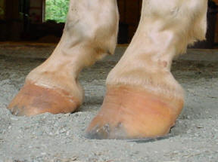
The club foot is usually denoted by the high heel and dished hoof wall. This can be caused by a genetic defect in the angle of the coffin bone, injury, or high/low syndrome (when a horse that typically stands grazing with one foot back, causing the heel to grow down and a flare to form on the toe of the hoof wall.
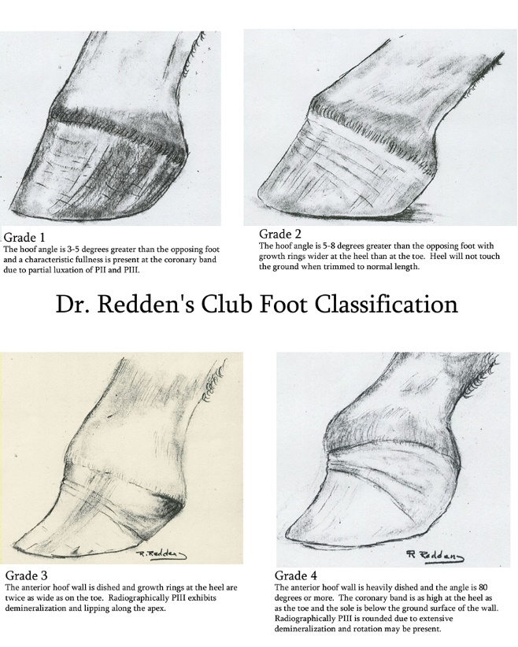
The club foot is painful and horses with a club foot can become lame. In some cases, with changes to management, feeding, massage, correct and frequent trimming can improve the condition.
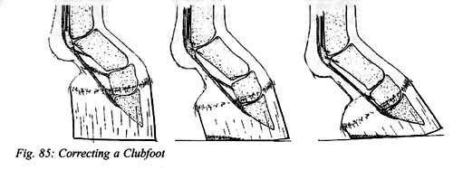
If you suspect that your horse has a club foot, you can ask a vet to take a radiograph of your horses hoof. There is a lot of information you can glean from an x ray. It will show you the angle and location of the coffin bone.

Trimming:
The next step is to have an experienced hoof trimmer, make small changes to the hoof every 2-3 weeks. The goal is to help the horse develop the back of the foot so that the horse can land heel – to – toe. They will keep the toe at the proper length/angle to help prevent flaring (which will pull the coffin bone away from the inside of the hoof wall). They will also slowly lower the heel, over time to give the internal structures time to adjust, (because the back of the horse’s feet will probably not be “ready” yet to absorb the heel first landing!

What Can The Horse Owner Do to Help?

- The club foot is sometimes referred to high/low syndrome. This refers to one hoof being a different size than the other. The size difference has an effect all the way up the leg and into the rest of the body. For example, the affected hoof may have a shortened stride, cause tension in the joints, ligaments, tendons, bones and muscles in other parts of the body. An Equine massage therapist and chiropractor is an invaluable resource for helping to relieve tension and strain in the muscle. Research suggests that the stretching the affected limb forward and massaging the groove between the scapula and neck/body of the horse can be helpful.

- Exercise is very important! Ride or hand walk the horse on a variety of terrain. Smooth flat ground, hilly areas, rocky areas, etc., Again, use caution. If the horse has not been ridden in a while, go slow and put hoof boots on your horse if you notice that they are sore. Lunge the horse in both directions at the walk, trot and then canter if the horse is sound. If the horse has not performed exercise in a while then take it slow. Horses typically land toe first at the walk, so some trot work is important to give the horse time to work on heel first landing. If the hoof trimmer keeps the toe shorter it will help the horse land heel first, (over time)!!!

- If the horse is sore, hoof boots can protect the horse’s sole and frog during exercise times. The addition of a foam frog pad can add extra protection plus stimulate the back of the horses hoof, increasing blood flow to the foot speeding up the healing process.

- Sometimes horses develop a club foot from putting one front leg back under their bellies as they lower their neck down to graze or eat hay. One way you can help the horse is by feeding the horse hay higher off the ground from slow feed hay nets that are tied all around the pasture.

- Consider getting blood work done on your horse. Feed your horse a low starch, high fiber diet that is balanced. Consider getting your hay sampled at Dairy One and then you will have a base line for determining what other nutrients the horse needs. Here is a link to Dr. Kellon’s Equine Nutrition Cheat Sheet:

http://www.hoofrehab.com/NRC+Kellon%20quick%20glance.pdf

- The horse may also benefit from probiotics and a natural anti-inflammatory. Vood Food is an organic, all natural, very powerful safe anti-inflammatory supplement for horses that reduces inflammation quickly and it can help get your horse moving and speed up the healing process.

- The horse may have a weak and small frog that is infected with thrush. If so, some people treat the hoof with iodine soaks, copper tox, or a mixture of neosporine/athlete’s foot cream.

- The horse needs to step down and then lift the foot back up in order to pump blood. Horses are not meant to stand around for long periods of time eating in one spot. You might be interested in modifying your pasture set up to keep the horses moving. Paddock paradise is a management set up that tries to mimic what horses have evolved to do: walk, nibble, take a few steps, nibble on more plants, etc., a horse’s natural state of being in constant movement. This constant movement allows the horses feet to become and stay healthy.

http://www.all-natural-horse-care.com/paddock-paradise.html

