Suggestions for Preventing and Treating Thrush

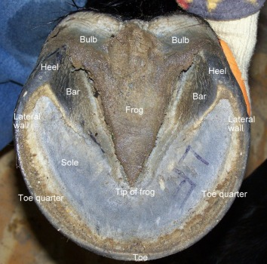
The horse’s frog plays an important role in absorbing energy when your horse moves. The picture to the right shows a healthy frog. It is wide, it would touch the ground, and it is continuous with the bulbs in the back of the foot.
Thrush is a bacterial/fungal infection of the frog tissue on a horse’s hoof. It is a foul smelling infection that can be very painful for your horse! Many factors can influence the development of thrush: environment, movement, diet, and management through correct trimming.
Some infections can become so severe that the horse tries to avoid landing on the back of their feet to protect themselves from pain. Over time, this toe-first landing, causes the internal structures in the back of the foot to shrink and lose their ability to absorb or dissipate the force of energy when each foot lands on the ground leading to mechanical founder.

Contributing Factors: Environment, Movement, Diet and Trimming
Horses that stand around in urine, feces and mud in a stall or pasture, are highly susceptible to thrush because there is not enough stimulation or sloughing action to keep the frog free from “skin” flaps that will trap bacteria or fungus.
As the frog grows, dry hard rocky ground helps to slough off old frog tissue to make room for new. To facilitate this, horses would benefit from pea gravel footing. The drainage improves the environment and the sloughing action removes old tissue, stimulates the bottom of the foot, and invigorates the internal structures, supporting healthy growth and correct movement.

To keep the foot healthy it is important that we:
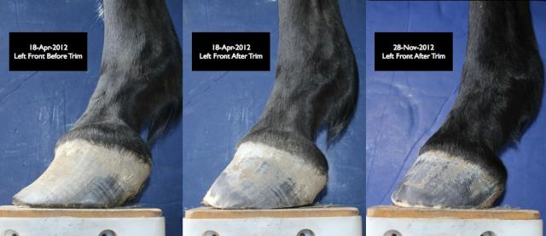
- Provide your horse with consistent, regular, and correct barefoot trimming (correct toe length and heel height to support the internal structures in the hoof.) The picture on the left, shows a horse with a long flared toe. This flare means that the coffin bone, (the horses toe) is separated away from the hoof wall. This horse is in a state of laminitis. The second picture in the middle, is after the trim. The last photo, was several months later of slow adjustments that has resulted in the horse’s hoof restored to a more correct state.

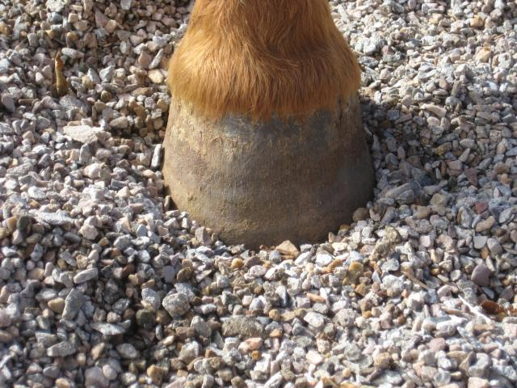
- Make positive changes to environment through fencing setups (paddock paradise), drainage, adding pea gravel, hills to walk up and down, and type of plants in the pasture.

- Make sure to clean the hoof each day and carefully remove flaps or debris.

- If you suspect that your horse has thrush here are some suggestions on how you might treat it.

  - Neosporin Plus Pain/Athlete foot cream mix together and put 15 cc in a syringe. Insert 3.5 cc into central sulcus each day. Treat until heals (may take 2-3 months.)
  - Anti-fungal soak, in a soaking boot, with warm water and iodine for 15-20 min per day.
  - Apple cider Vinegar/Tea Tree Oil soak in a boot. 1:1 ratio ACV to water
  - Copper-tox treatment- (see bottle for treatment protocol)

- Provide a low starch balanced diet (sugar diets lower pH in the hind gut and kill off good microbes), free choice quality hay (horses evolved to eat slowly throughout the day not large quantities two times a day), in slow feed boxes or nets, all over the pasture. You may want to consider learning more about Paddock Paradise.

- Test hind gut pH. Make sure it is around neutral. This will provide the optimum environment for the good microbes that you want there and thus improved absorption of nutrients. See diet suggestions to improve the pH of the hind gut. Offer probiotics to support hind gut microbes. They are vital to your horse’s health. They help break down biological molecules and provide your horse with the nutrients they need.

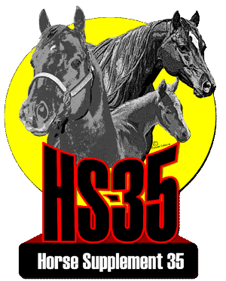
- Consider getting help to balance horse’s diet by getting a hay analysis done to determine the nutritional content of the hay. Then, providing a protein, fat, vitamin, mineral supplement to make up for what is lacking in the hay. (If trace minerals are not balanced they can prevent the absorption of nutrients.) You may want to send a sample to Dairy One, located here in NY! Some customers have seen an improvement in general health when offering HS-35, an all-around supplement that includes amino acids, vitamins, minerals, and probiotics.

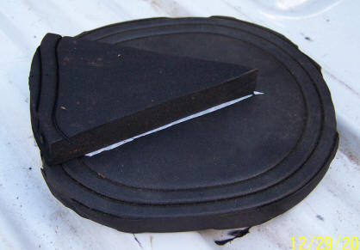
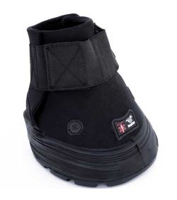
- Boots can also help your horse recover from thrush and improve the development of the hind foot. Pads (see photo below right) can be inserted into the boot that will provide soft pressure against the underdeveloped frog when small and weak. This will help the horse feel less sore as he or she moves across varied terrain. Over time, the movement increases blood flow to the foot to speed up healing, and the frog is receiving the stimulus to improve growth. As the horse becomes less sensitive, you can change the size and density of the pad to increase stimulus which will increase blood flow to the foot, thus improving the development of the internal and external structures of the back of the foot. You may want to consider Easy Care boots. Many customers like the Rx model to the upper left. Your barefoot trimmer can assist you in finding the right type of boot as well as fitting the rehabilitative frog pad, to suit your horse’s needs.

The goal of every horse owner should be to keep their horse in a natural state. That being, a barefoot hoof. Sometimes, horse owners are told that their horse requires a shoe if it is to become sound. Shoes unfortunately may appear to fix the problem, but are a temporary fix. They have not been shown to restore the health of the hoof over time. A metal shoe does not allow the foot to expand and contract as it was designed to do. In fact, a shoe forces the hoof to take the force of each landing on the hoof wall, which it is not designed to do.

When the horse lands, without the shoe, the heels and the frog take the brunt of the load; the combination of frog, blood and the digital cushion help to absorb the force of impact. With a shoe the foot is robbed of its ability to expand/contract and therefore upon impact, the energy from the landing, has been shown to travel up the bones and joints destroying the internal structures.

Shoes are sometimes applied when a horse is tender footed. Instead of making long term appropriate changes to environment, movement, diet and regular corrective trimming, the shoe acts as a band-aid lifting the foot off the ground, “providing support” to the foot. The only problem is this prevents the frog and digital cushion from doing their job of pumping blood-thus causing the internal structures of the hoof to waste away!

I hope that this article will help educate horse owners on ways to develop healthy horses that are happy and sound.

