The Dangers of Drought Stress on Pasture Grasses
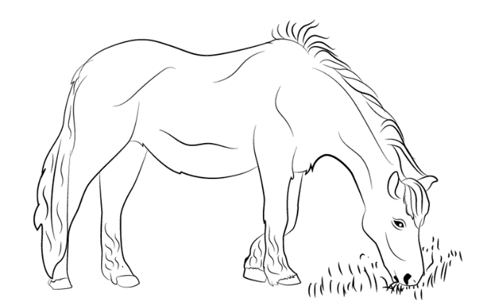
Drought conditions drastically effect grasses. While they continue to perform photosynthesis (a process by which they harness the power of sunlight to convert CO₂ and H₂O into different types of sugars). However, plants get smart and switch to storing energy, instead of using it to grow, as a means to protect themselves until the rain comes.
Grasses can be organized into two basic categories, cool-season and warm-season. As the names suggest, the major differences between the warm and cool season grasses, indicates the temperatures in which they seem to grow best. Cool season prefers 65 – 75 F, and warm season grasses enjoy a balmy 80-90 F temperatures.

Cool-season grasses respond to drought by storing a type of sugar called fructans. They are very large and complex.

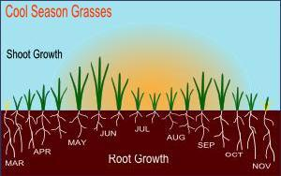
Examples of cool-season grasses:
- Kentucky bluegrass
- Fescues
- ryegrass

*Fructans are known to cause laminitis in horses!
Warm-season grasses, store sugar or carbohydrates in the form of starch. Starch is also a large molecule that is made up of many smaller glucose molecules.

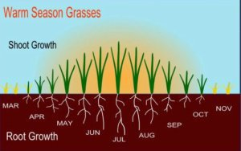
Examples of warm-season grasses:
- Bahiagrass
- Bermudagrass
- Buffalograss
- Centipedegrass
- St. Augustinegrass

As mentioned above, the sugars are stored for a time when the conditions are right for growing again. When the rain finally comes the plant starts to create very specialized molecules called enzymes that can break down the big starches and fructans into small sugars so the plants can use them to grow.
When your horse eats the sugars it reduces the pH of the hind gut, kills off important bacteria and when the bacteria die they produce endotoxins that lead to inflammation. The inflammation causes the coffin bone in the horse’s hoof to detach from the laminae and tip of bone pushes down on the sole of the hoof causing extreme pain resulting in – Laminitis or Founder.

Preventative Strategies

