The Popsicle Stick Hoof Measuring Tool
Shelley Walker Next Step Trimming

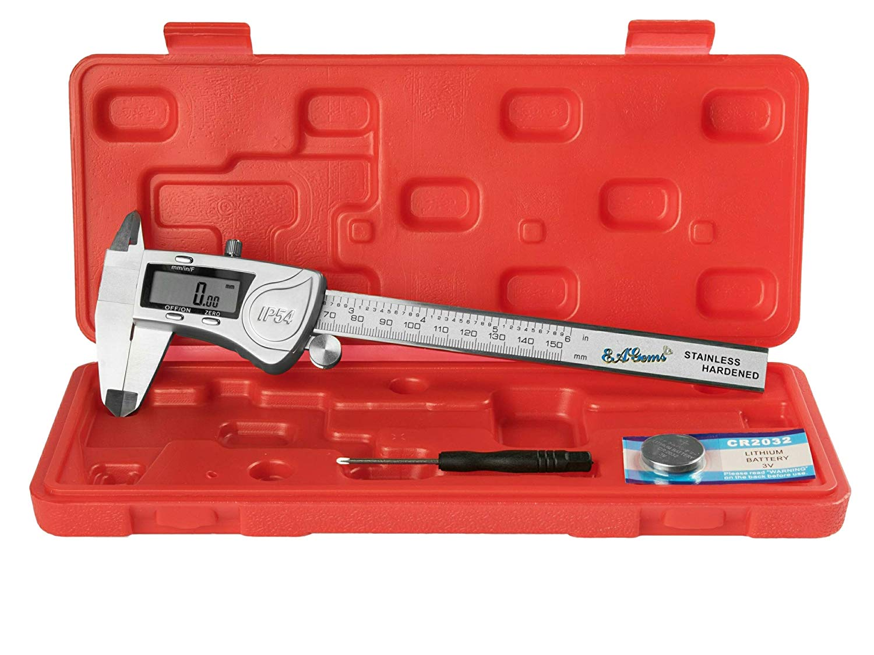
We can gather useful information by measuring our horse’s hooves. Using a measurement tool allows us to record and determine the condition of the hoof and perhaps determine some basic information that will allow us to determine whether the horse’s hoof is relatively healthy, or imbalanced and unhealthy.

My favorite tool, due to accuracy, is an electronic caliper. They can be purchased on Amazon and they usually cost around $20.00.

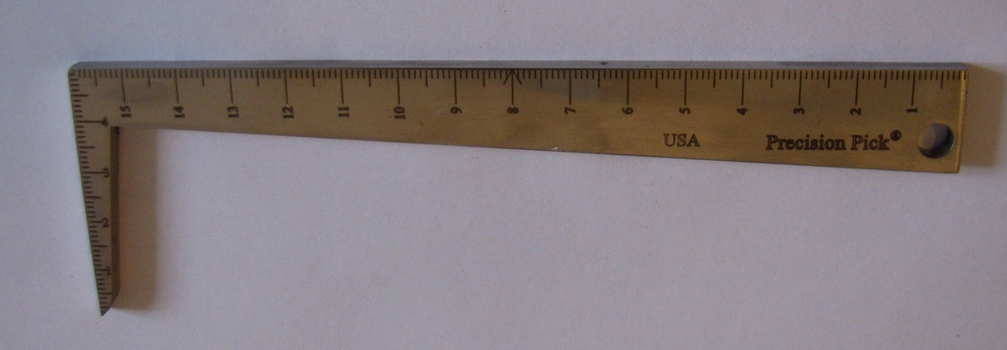
One that I also like to use is a Precision pick. They come in both metric and inches. You want to keep the surface protected. Otherwise it gets scratched up and it is hard to read. You can use this tool to measure depth, length, width, angles, and clean a hoof too!

However, if you want something very inexpensive, you won’t mind carrying in a pocket or using around your horse; then grab a Popsicle stick! This type of measuring tool is light, cheap, easy to make and small enough to carry. You can make one quickly and suddenly you are armed with a tool that will enable you to look at your hoof. Plus, as an added bonus, you will feel good knowing that you are reusing something that you were going to throw away.

To make a Popsicle stick measuring tool, all you need is:

- Ruler
- Sharpie marker
- Popsicle Stick
- Additional water proof marker colors

Directions:
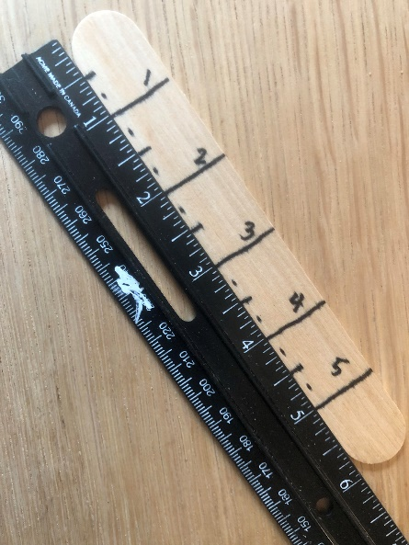
- Lay your Ruler down next to your Popsicle stick and line up one end with the very beginning of the ruler.
- Then, label the Popsicle stick with a Sharpie as shown in the photo.
- You can add additional colors to denote specific things you will look for when measuring the horse’s hoof. I will explain more in the chart.

The next step is to go grab your horse and secure him or her on cross ties. Now, that you have your victim secured, you are ready to start using your Popsicle stick measuring tool!

What can the Popsicle Measuring Tool do?
I have created a chart that you can print out and refer to when using the measuring tool. It explains what you can measure, why you would take the measurement and what good perimeters would look like. You will also find a place for you to record information that you might find helpful as you work with your trimmer to help make important adjustments. It is also helpful to take pictures before and after trimming to note wear and tear. This can give clues to how and how often your horse moves. This is valuable information that will allow you to make changes to your horse’s conditions and routines to improve health and performance.

There are some other things that you can investigate to determine the health of your horse’s feet. You can look at your horse’s frog. It should be wide, dark, not have a smell, firm and the central sulcus should be closed. If the frog is soft and squishy, smells like garlic, rotting things, or see white powder/black tar you have a thrush infection and it needs to be treated right away.

Measurement | Description | Location | Parameters
Hoof Length | This refers to the tip of the toe to the edge of the heels. | 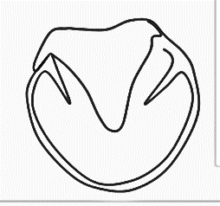 | They typical 15-16 hh horse will have a 4.5 – 5.0 inch length.  Front feet are usually rounder.
Hoof Width | Measure width at the widest point, from heel to heel. | 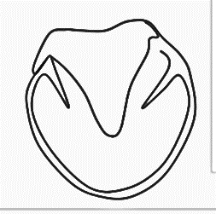 | They typical 15-16 hh horse will have a 4.5 – 5.0 inch length.  Back feet are typically more spade shaped.
Heel Distance | Measure the space between the inside of each heel. |  | You want a wide distance between the heels.
Collateral Grooves | Put the stick into the grooves alongside the frog, at the half way point. This gives you an idea of depth of sole. Determine depth by looking for the measurement that lines up with the hoof wall. |  | You want the groove at the deepest part to be about 0.5 – 1.0 inch.
Hoof Wall Length | Measure from the hairline to the end of the toe. | 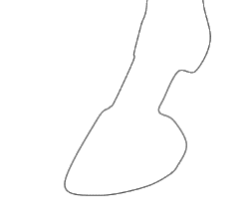 | A typical 15-16hh horse will be around 3-3.5 inches. However each horse is different. Ponies are less and draft are more.
Heel Height | Measure the hairline to the bottom of the heel (where it touches the ground) |  | A heel height of around 1.0 to 1.5 inches is best.  *The angle of the Toe length should match that of the heel angle.
Hoof Wall height | Insert along the hoof wall. |  | The height of the hoof wall should be around 1/16 to 1/8 inch
Toe to Frog/Heel Proportion | You want to measure with your stick as shown to the right. The stick will be lined up at the tip of the hairline to the ground. | a b | To have a hoof that is in balance, you want to see 1/3 of the hoof in region a, and 2/3 of the hoof in region b.

Hoof Measurement Chart Month: _________
Date | Hoof | Hoof Length | Hoof Width | Heel Width | Collateral  Grooves | Hoof Wall Length | Side view  Balance
 | RF
 | LF
 | RR
 | LR
 | RF
 | LF
 | RR
 | LR
 | RF
 | LF
 | RR
 | LR
 | RF
 | LF
 | RR
 | LR

