Treatment and Prevention of Fungal Infections of the Hoof Wall
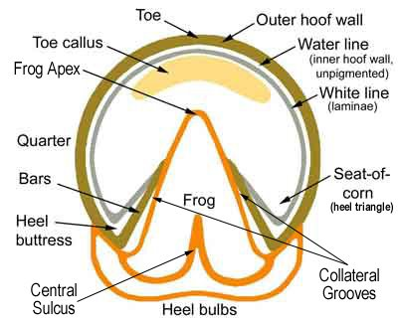
The hoof wall consists of several layers including the exterior hoof wall, the non-pigmented water line, the white line and the sensitive laminae.
The outer hoof wall protects the inner structures of the foot.

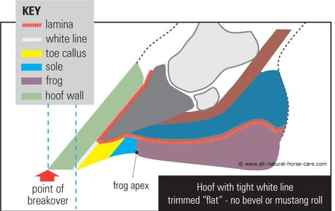
When cracks or objects invade the hoof wall or the white line, it allows bacteria and fungus to enter the inner structures, separating the connection between the deep layers that hold the hoof wall to the coffin bone.

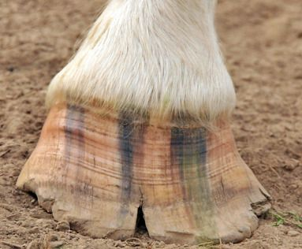
Cracks form for different reasons. During different times of the year, horse’s feet may become wet for a couple of days and then their environment dries up and their feet become dry again. If this change continues day in and day out their feet may start to form cracks. In addition, if the horse does not get regular correct trimming, the hooves may grow too long and start to flare. The hooves are weakest at the ends and they start to naturally split and break off.

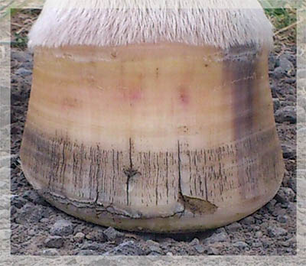
Diet also plays a part in the development of a healthy hoof. Horses that do not have a balanced diet may experience striations, lack of growth, or other issues leading to cracks and chipping.
Striations due to improper diet.
Hooves grow from the coronet down. Healthy growth is coming in due to changes in this horse’s diet.
The key is to provide them with a balanced diet that provides the hoof as well as the rest of the body with the necessary nutrients it needs to grow, provide the structure needed to be strong, and sound. Poor hoof quality can be influenced by the types of protein. Horses that are fed a lot of grain and do not have access to adequate forage may be lacking the amino acid methionine. Horses that are fed mostly hay may require more fatty acids. Or the horse may be lacking biotin, Vitamin E, correct balance of minerals (a deficiency in minerals like calcium, phosphorus, magnesium and selenium but particularly copper and zinc).
Sometimes you might see horizontal cracks in the hoof wall. This type of crack might be caused by an abscess that blew out through the hoof wall. They generally do not cause too many problems and typically just grow out.
If a crack appears and a pathogen (bacteria and fungus) enters the crack it will start to grow and spread under the hoof wall.

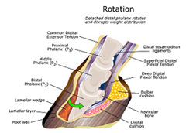
Preventing a fungal or bacterial infection under the hoof wall starts with frequent correct trimming to prevent flaring because flares put pressure on the toes and quarters and when the horse steps down, the energy from the landing, causes the hoof wall to bend and crack. Long toes and quarter flares force the horse to walk differently and put a lot of pressure on the toe. Since the hoof wall doesn’t bend, it starts to wear on the connection between the coffin bone and the hoof wall, leading to separation (laminitis). The picture on the right shows the coffin bone separated from the hoof wall, rotating down into the sole of the hoof. This is extremely painful for the horse.

If your horse is starting to get a crack, talk to your hoof trimmer about possible causes and how to manage it. If the crack is growing deeper, and infection is suspected you can call a vet for advice. Daily management requires that you keep the crack clean by using a hoof pick to clean it out.
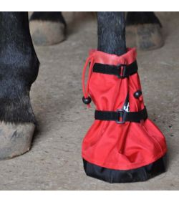
You can also use a mild solution of borax and water and scrub with a tooth brush.
If the crack is increasing in size, you may want to have the hoof trimmer make sure that the horses toe is kept reasonably short to reduce pressure. Then, expose the infected area by cutting out specific parts of the hoof wall to expose the infection to light and air.
Then, it will be necessary to soak the hoof 2 to 3 times a week and keep the hoof as clean as possible. Soaking can be accomplished by using a bucket or a soaking boot depending on the horse. Continue to treat the horses hoof until the infection has gone away and healthy growth is coming in.

Soaking Treatments:
Gentle but effective soaking treatment might include a mixture of a ¼ cup of apple cider vinegar to a gallon of water. (2 parts warm water). Tea tree oil is an antifungal. You can also add 1 tablespoon of tea tree oil and dilute it in 1/8 cup of olive oil. Then, add 2 tbsp of the diluted tea tree oil to the apple cider vinegar water. You can also put this mixture into a squirt bottle to treat affected areas. Be sure to shake the mixture thoroughly.
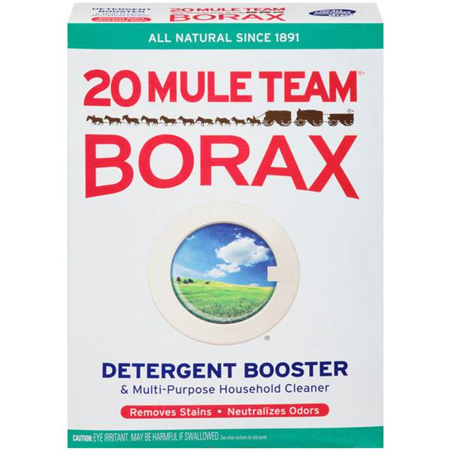
Borax is an anti-fungal agent that is used primarily as a detergent. If you mix 1 tbsp of Borax, in ½ gallon of water you can soak the infected foot for 20 minutes three times a week to help reduce infection.

Summary of Causes and Treatment:

- Vertical hoof cracks can allow foreign materials to enter the hoof causing disease. If an infection between the hoof wall and sensitive interior forms, it can cause separation of the coffin bone from the hoof wall.

- Correct and frequent trimming to keep the hoof balanced at the toe and quarters will help prevent separation and cracks from forming.

- Diet also influences hoof health. Making sure that the horse has a balanced diet will allow for proper growth and stability.

- Moisture and exercise will also influence cracking. Wet and dry environment can lead to swelling and shrinking of the hoof wall leading to cracks.

- Treatment suggestions include exposing the infected area by debriding the hoof wall to expose the region to light and air.
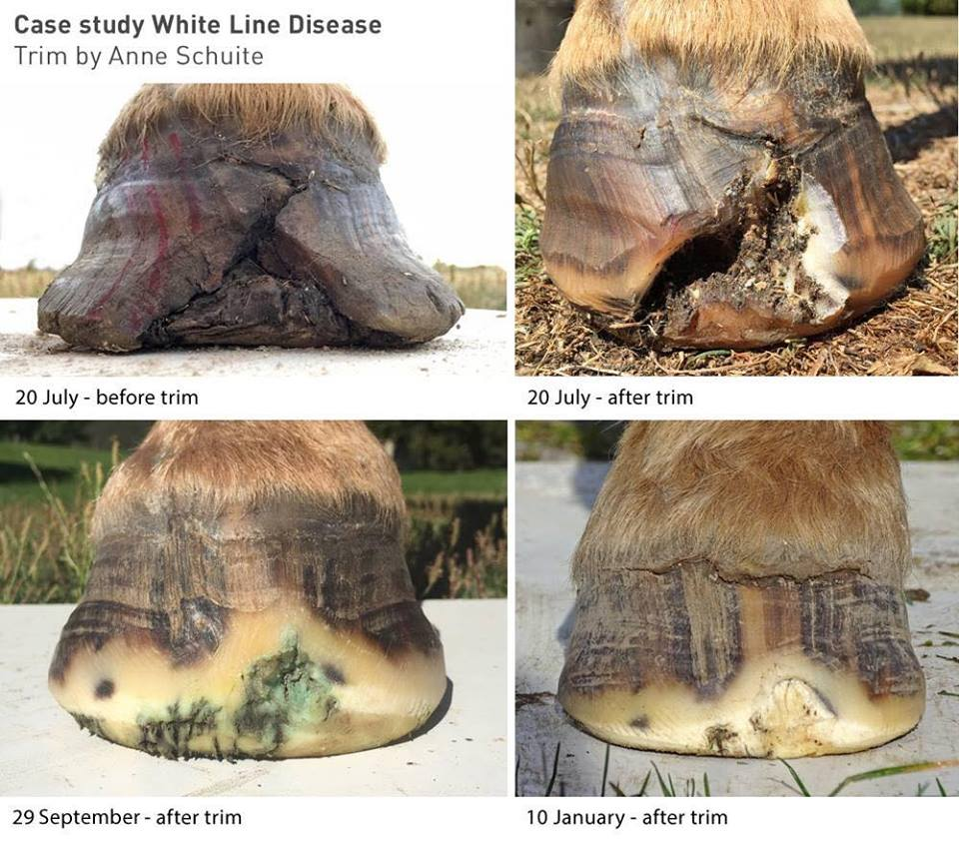
- Then, the owner must soak the foot with apple cider vinegar/water/tea tree oil or borax/water mixture to kill the bacteria and fungus. Treat the foot to a soak 2 to 3 times a week depending on the infection until the infection clears up.

- If the horse is not sore make sure that the horse has a clean dry environment and lots of exercise to increase healthy growth.

Sources:
http://www.naturalhorsetrim.com/FEEDING%20THE%20HOOF,%20Dr.%20Kellon.pdf

http://www.hoofrehab.com/

http://www.thehorse.com/articles/16461/white-line-disease-diagnosis-and-treatment

https://equusmagazine.com/management/field-guide-hoof-cracks-55256\

http://www.thinklikeahorse.org/index-28.html#whiteline

